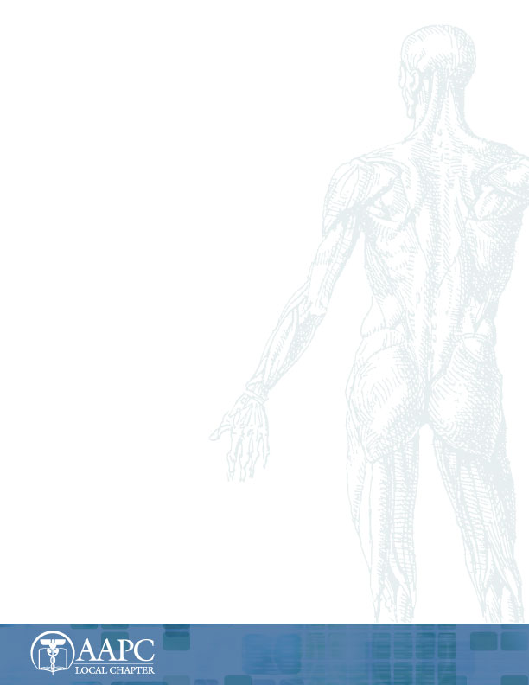AAPC ICD–10–CM
General Code Set Training
Learn to code for ICD-10-CM and prepare for the ICD-10 Proficiency Assessment
General Code Set Training with Complete Guidelines and Coding Exercises

Hosted by the Weston Florida Chapter

WHEN: April 5th & 6th 2014 TIME: Breakfast & Sign-In 7:00am
Start Promptly at 8:00am

WHERE: Courtyard by Marriott
620 N. University Drive
Coral Springs, FL 33071

Special Room Rates Contact
Jenna Nichols 954-905-1024

COST: $325.00/Pay Pal $335.00

- 16 CEUS – 2-day Boot Camp
- AAPC instructor lead
- Limited space available
- Refunds–Registration fee is non-refundable.
- Inclement weather - If there is inclement weather and the AAPC trainer cannot make the meeting, AAPC will reschedule. If the AAPC trainer is able to make the meeting, all cancellation agreements will be in force.
- You must be a member of AAPC to attend. Membership can be purchased for $125 at www.aapc.com.
- Breakfast, Lunch & Snacks Included.
You cannot register without a current AAPC membership number.

REGISTRATION FORM – Weston Florida Chapter- ICD-10-CM Training

⃝ $325 or $335 for registration
⃝ $60 for Timed Proficiency Assessment*
⃝ $195 for At Your Own Pace Proficiency Assessment Course*

*Successful completion of either of these assessment options (Timed or At Your Own Pace) by September 30, 2015 will satisfy AAPC’s ICD-10 certification maintenance requirement and demonstrates proficiency of ICD-10-CM format and structure, groupings and categories of codes, ICD-10-CM official guidelines, and coding concepts.

NOTE: Although not offered at the Boot Camp, attendees may choose to purchase the Timed Proficiency Assessment ($60) through the chapter, or the At Your Own Pace Proficiency Assessment Course (which is offered at a reduced price of $195) along with registration, through the chapter.

NAME: ___________________________________________________

AAPC#:____________________

ADDRESS: ___________________________________________________________________________

EMAIL: _______________________________________ CONTACT PHONE #: ____________________

Chapter you currently attend: __________________________________________________________

AMOUNT ENCLOSED: ______________ (Checks & Money Orders accepted)

CHECKS SHOULD BE MADE PAYABLE TO: AAPC Weston Florida Chapter

SEND REGISTRATION PAYMENT TO: Randee Herner
9600 NW 73rd St.
Tamarac, FL 33321

QUESTIONS/CONCERNS: Please call or email Randee @ 954-401-4133
aapc.weston@gmail.com

